

**Table of Contents**

**1. Abstract** .......................................................................................................................... 03

**2. Objectives** ....................................................................................................................... 03

  2.1 Primary Objective ................................................................................................. 03

  2.2 Functional Objectives ........................................................................................... 03

  2.3 Non-Functional Objectives ................................................................................... 03

**3. Problem Statement** ....................................................................................................... 03

**4. Scope** .............................................................................................................................. 04

**5. Methodology** ................................................................................................................. 04

  5.1 Process ................................................................................................................. 04

  5.2 Tools & Platforms ................................................................................................ 04

**6. Technology Stack (Mobile App)** ................................................................................. 04

**7. Design Principles** .......................................................................................................... 05

**8. Visual Models** ............................................................................................................... 05

  8.1 Flow Chart ........................................................................................................... 05

  8.2 ER Diagram ......................................................................................................... 06

**9. Timeline (Gantt Chart)** ............................................................................................... 07

**10. UI/UX Design** ............................................................................................................ 07-10

10.1 Home Page ......................................................................................................... 07

10.2 Emergency ......................................................................................................... 03

10.3 Bus Schedule ...................................................................................................... 08

10.4 News .................................................................................................................. 08

10.5 Blood Donation Page ........................................................................................ 09

10.6 Train .................................................................................................................. 09

10.7 Profile ................................................................................................................ 10

10.8 Notification ........................................................................................................ 10

**11. Risk Analysis** .............................................................................................................. 11

**11. Limitations** .............................................................................................................. 11

**12. References** ................................................................................................................... 11

**1. Abstract**

This project is about creating a helpful mobile app for the people of Kurigram. In many situations like emergencies or daily needs citizens struggle to find reliable information. Important services such as doctor contacts, ambulance numbers, transport schedules, blood donors, or rental housing are often scattered across Facebook posts, printed posters, or word-of-mouth. That’s confusing and unreliable.

Our goal is to make life easier by putting all this essential local information into one easy-to-use app. Whether someone needs a doctor, wants to find a nearby bus, or is looking for a blood donor in an emergency, they’ll be able to find it in seconds.

The app is built using **Flutter** (a mobile app framework) and **Firebase** (a backend system for storing data). It works in **real-time**, so new updates appear instantly.

**2.Objectives**

**Primary**: Develop a cross-platform mobile app to connect Kurigram citizens with verified public service data.

**Functional Objectives**:

* User login and role-based access (User/Admin)
* Add/view/search service data (health, transport, rent, etc.)
* Admin approval for sensitive or public content
* Feedback and rating functionality

**Non-Functional Objectives**:

* Response time under 2 seconds
* Secure authentication and data validation
* Offline support for emergency module
* Compatible with low-end Android devices

**3.Problem Statement**

People in Kurigram often can’t find important service information like doctors, blood donors, transport, or emergency contacts. Information is scattered in social media, posters, or word-of-mouth — making it hard to trust or access quickly. There’s no proper app that puts everything in one place.So, we are making a simple mobile app to help citizens see and share local service info easily in Bangla or English. This will save time, improve public help, and make Kurigram smarter.

**4. Scope**

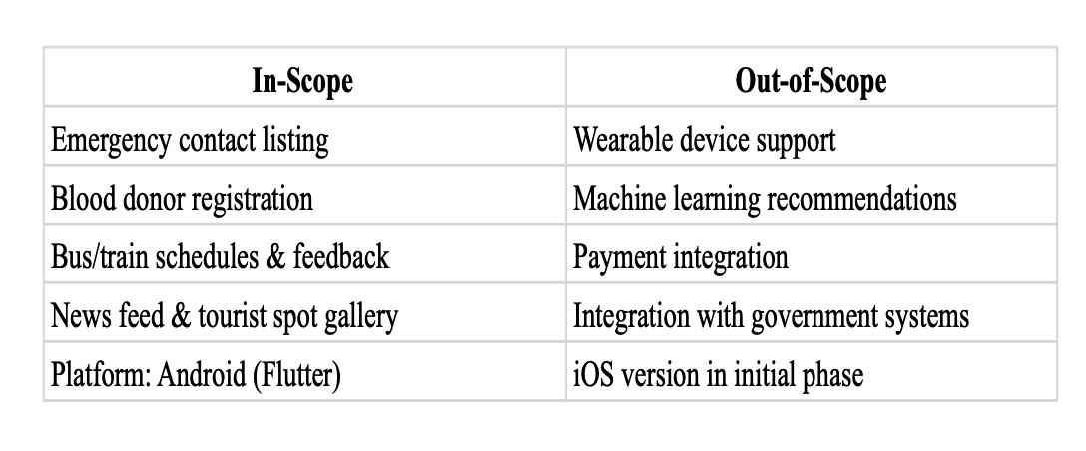Table: Table of Scope

**Included Services:**

• Emergency Services (Police, Fire, Ambulance)

• Doctors & Hospitals

• Blood Donor List

• Educational Institutes

• Hotels & Restaurants

• Courier Services

• Transport Info (Bus, Train)

• Electricians & Mechanics

• House Rent Information

• Loans & NGOs

• Kurigram News

• Tourist Attractions

**5. Methodology**

* **Process**: Agile   
  **Version Control**: GitHub
* **Project Planning:** Trello
* **Communication:** Discord
* **Diagramming:** PlantUML, Draw.io
* **Design Tools:** Figma,Canva

**6. Technology Use (Mobile App)**

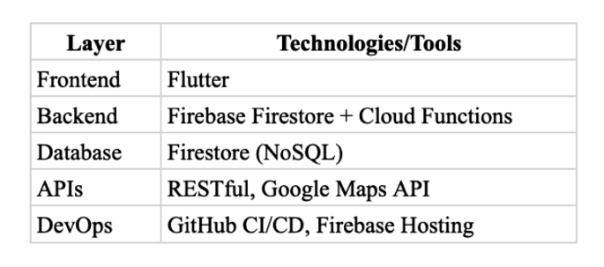

Table: Table of Technology Stack

**7.Design Principles**

* **Material Design**: Clean, modern UI using Google standards.
* **Responsive Layout**: Works on all screen sizes.
* **User-Friendly**: Easy navigation, Bangla-English support.
* **Low-End Device Ready**: Optimized for slower phones.
* **Cross-Platform Ready**: Android now, web/iOS later.
* **Documentation**: Clear guides for users and admins.

**8.Visual Models:**

**8.1 Flow chart**

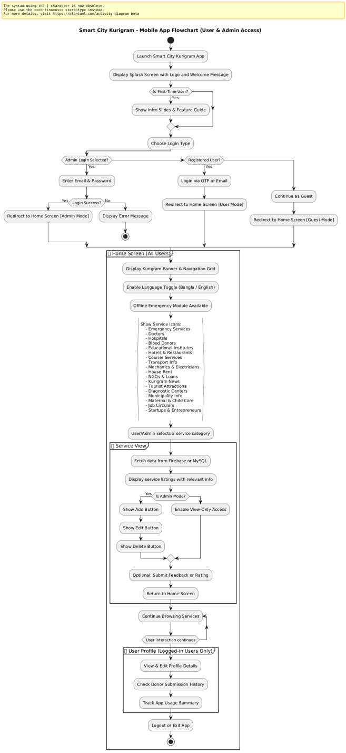

Fig: Flow chart of Smart City Kurigram

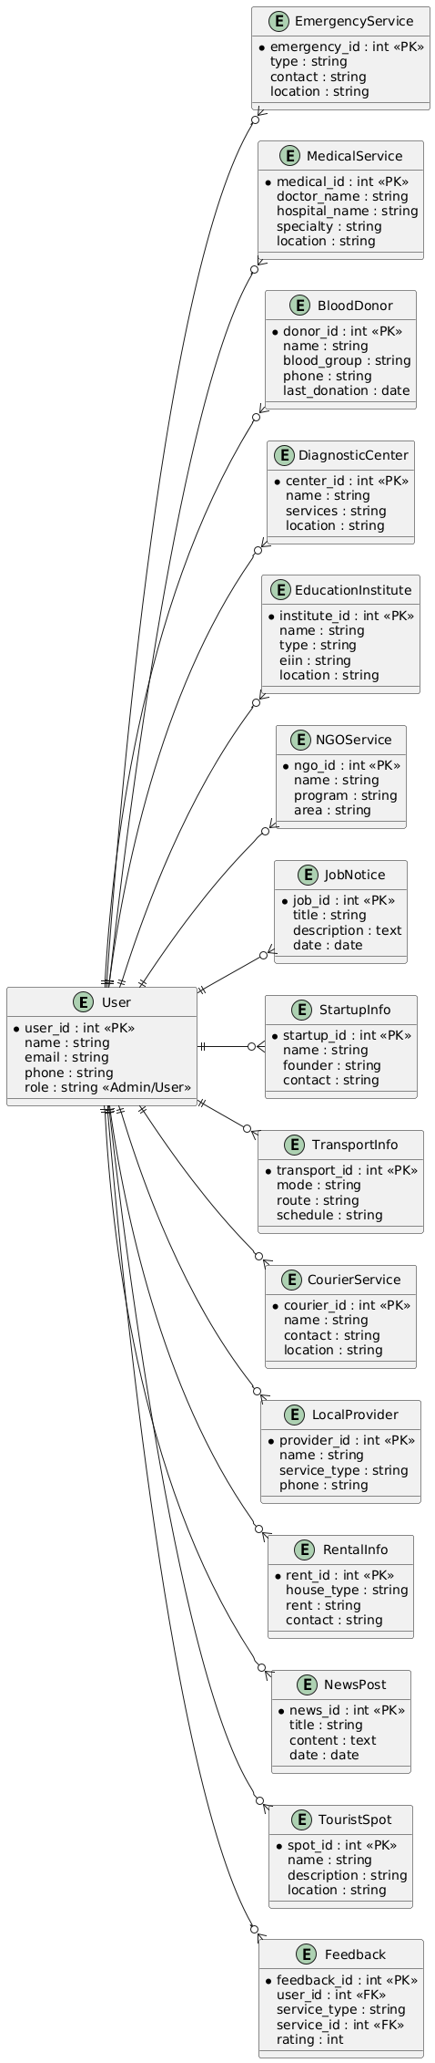**8.2 ER Diagram**

Fig: ER Diagram of Smart City Kurigram

**9.Timeline (Gantt Chart)**

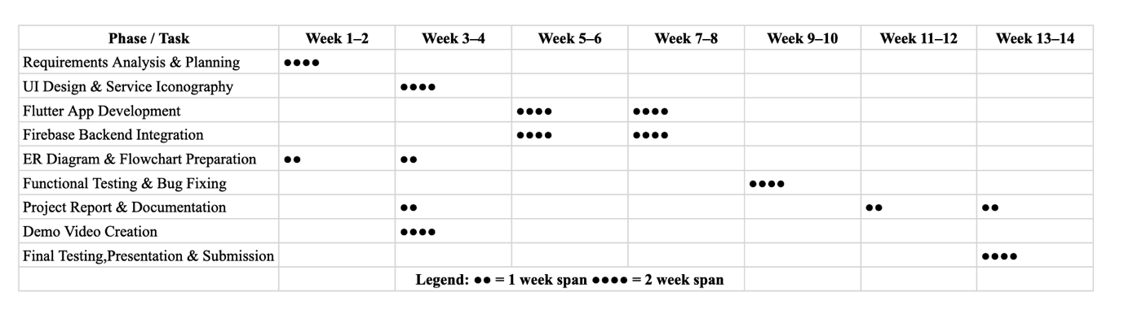

**10. UI/UX Design**

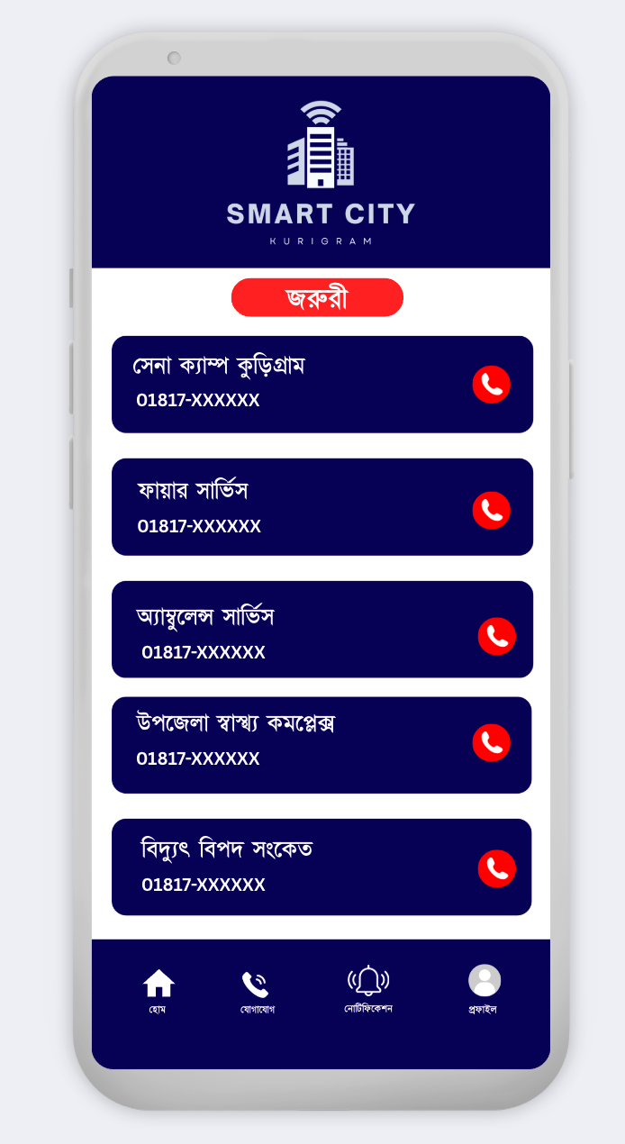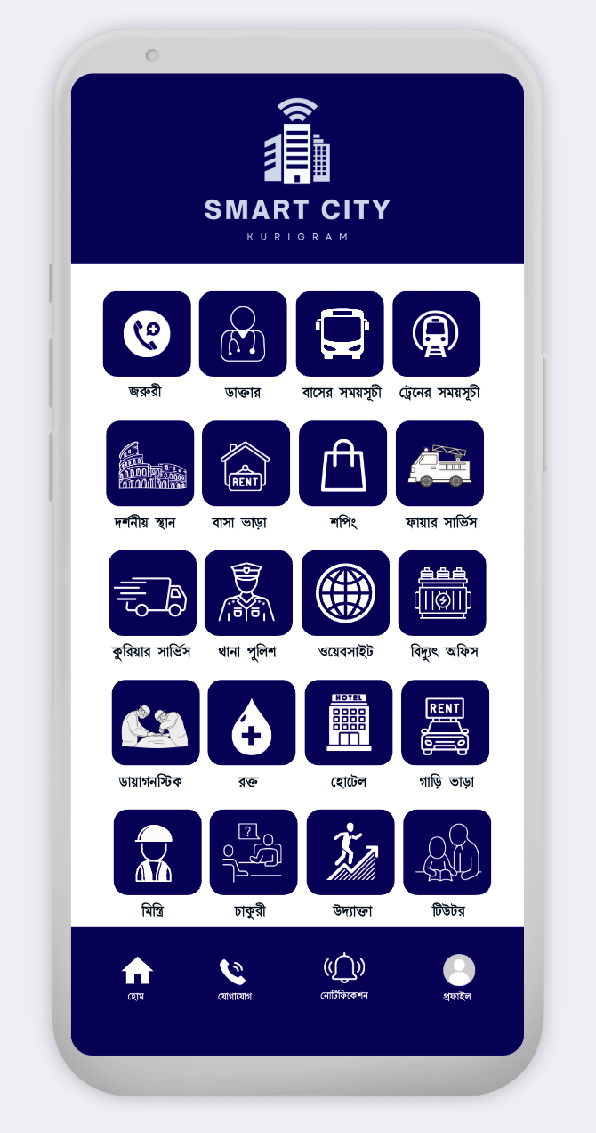

Design: UI Mockups of Smart City Kurigram (Home Page). Design :Emergency page

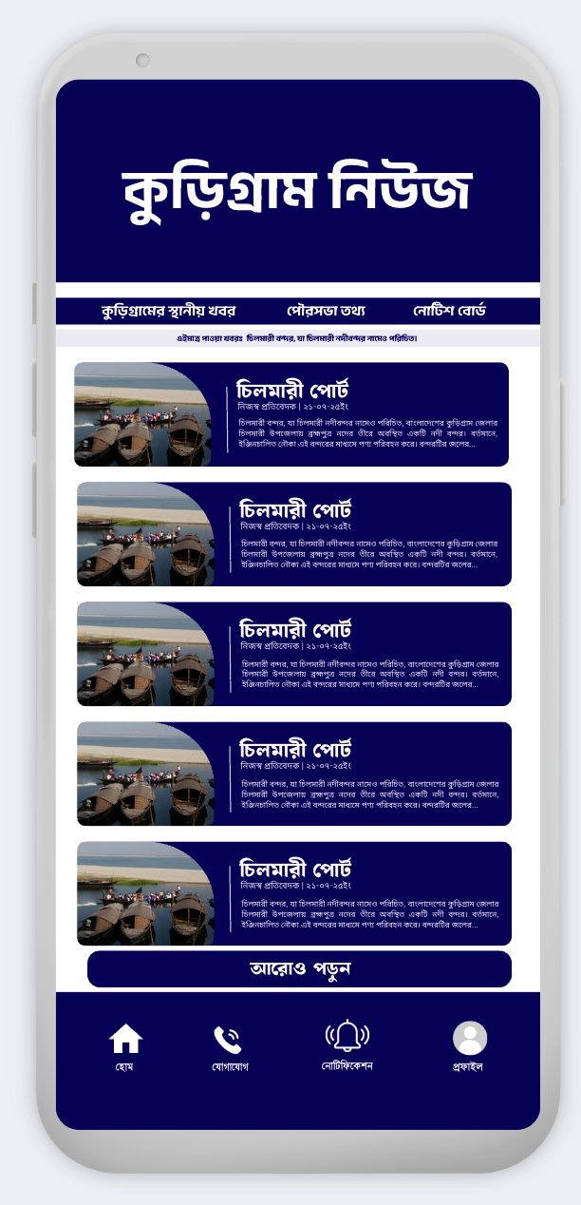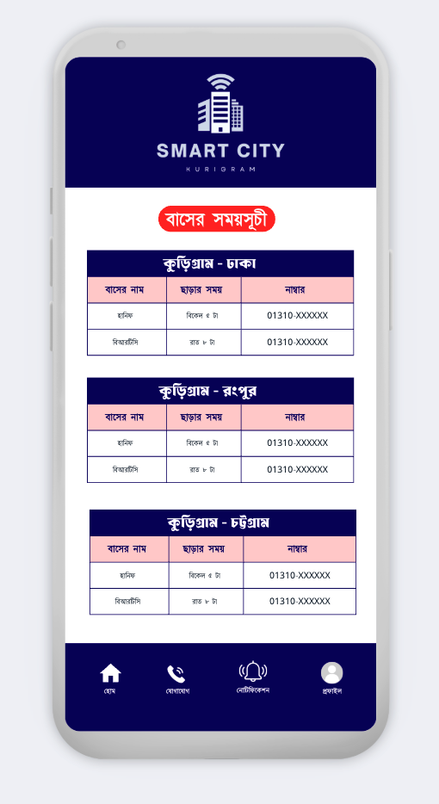

Design: Bus Schedule page Design :News page

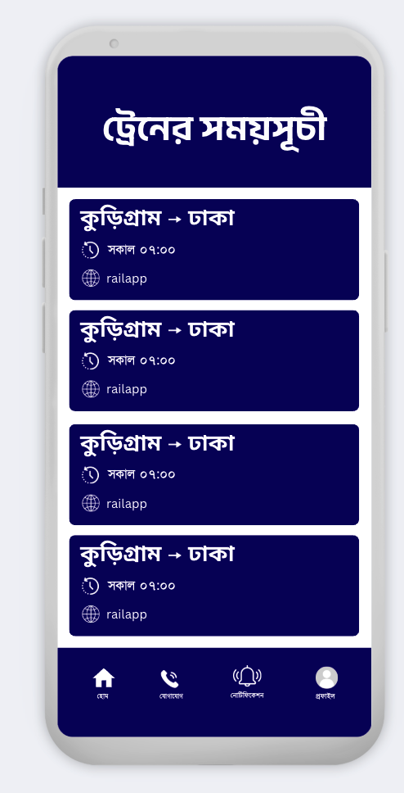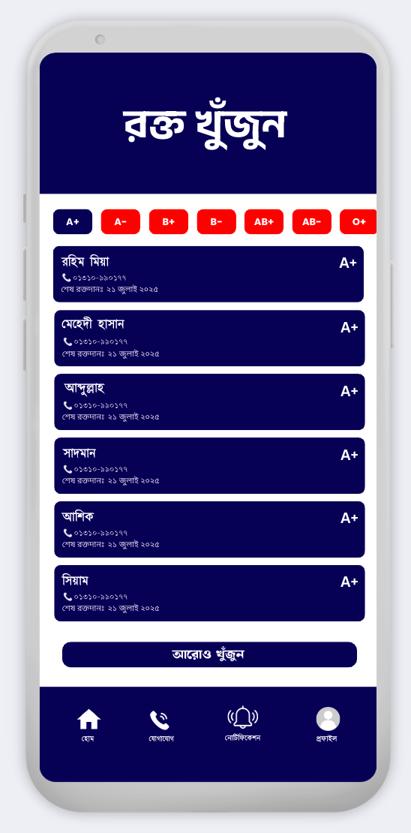

Design: Blood Donars page Design :Train Schedule page

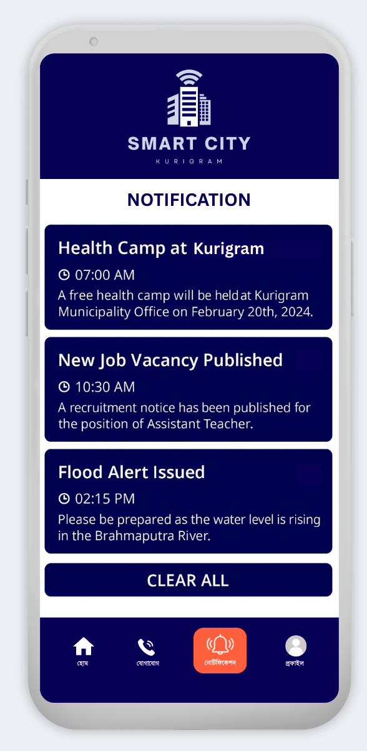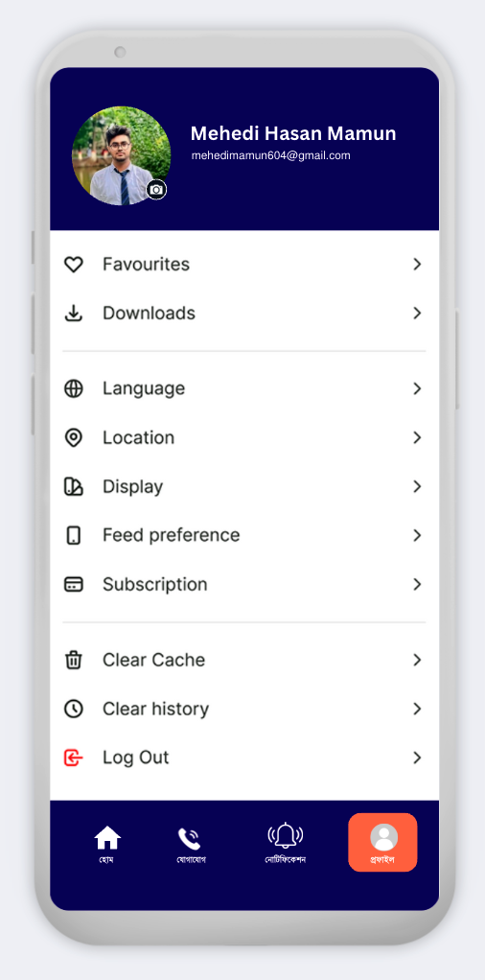

Design: Profile page Design :Notifications page

**11. Risk Analysis**

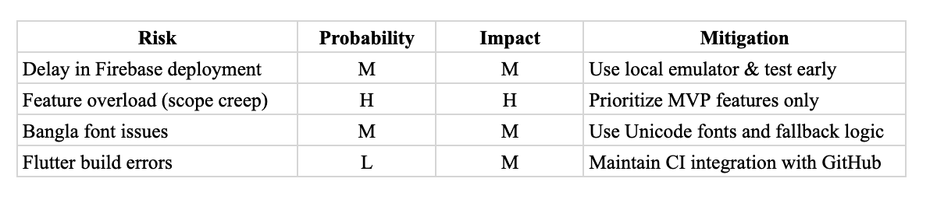

**12. Limitations**

1. **Offline Service Browsing Not Fully Supported**   
    – Although emergency contacts can be cached offline, most service modules (e.g. transport, hospital info) still require internet connectivity.
2. **Limited Admin Role Hierarchy**   
    – The current version supports basic Admin access. Advanced roles like Super Admin, Editor/Admin segmentation are not yet implemented.
3. **QR Code / Smart Tag Integration Missing**   
    – Features like service-specific QR codes or donor profile tags are planned for future updates but not available now.
4. **Map-Based Navigation Still Basic**   
    – Users see location text, but live map pins or directions (e.g. Google Maps integration) are not added yet.
5. **Push Notification Logic in Early Stage**   
    – Notifications are shown inside the app, but real-time push alerts (via Firebase Cloud Messaging) are still under development.
6. **No Cross-Platform Deployment Yet**   
    – The app runs only on Android via Flutter. No current release for iOS or web version, though planned in future phases.
7. **Service Rating System Is Optional**   
    – User feedback exists, but public review display or average ratings per service are yet to be integrated.
8. **Limited Browser Integration**   
    – No browser extensions exist yet, but architecture supports future integration with Chrome or Edge using web wrapper methods.

**13. References**

* Flutter Docs: <https://flutter.dev/docs>
* Firebase Guides: <https://firebase.google.com/docs>
* Project GitHub Repo: https://github.com/Mehedi-16/CodeWithFlutter/tree/main/Smart%20City%20Kurigram